
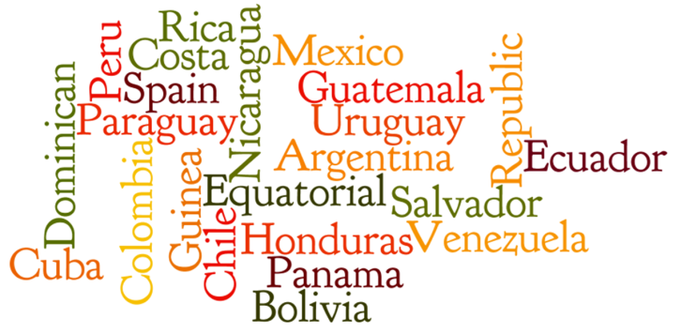
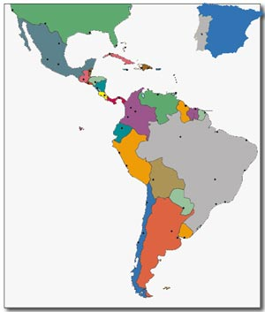
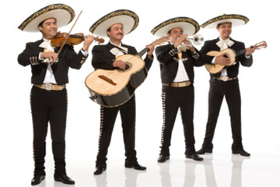
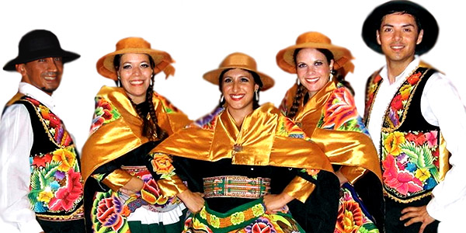
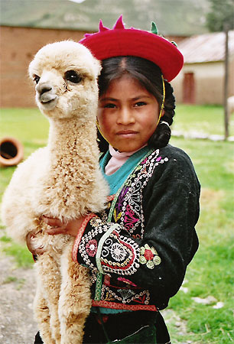
HISPANIC COUNTRIES, CAPITALS & NATIONALITIES

Across
2. ITS CAPITAL IS ASUNCION
4. WHO WAS BORN IN EL SALVADOR
5. CAPITAL OF NICARAGUA
7. ITS CAPITAL IS LA PAZ
10. ITS CAPITAL IS BOGOTA
11. LOCATION OF PUERTO RICO
12. WHO WAS BORN IN GUATEMALA (MASC)
16. CAPITAL OF CUBA
20. WHO WAS BORN IN ECUADOR
23. COSTARRICENSE IS THE NATIONALITY
24. WHO WAS BORN IN SPAIN (FEM)
26. IS LOCATED IN AFRICA
28. WHO WAS BORN IN VENEZUELA (FEM)
30. ITS CAPITAL IS SANTO DOMINGO

* WHO WAS BORN QUESTIONS REFER “NATIONALITIES” LIKE PERUANO, COLOMBIANO, MEXICANO, BOLIVIANO, ETC.
Down
1. LOCATION OF SPAIN
3. ITS CAPITAL IS MADRID
6. ITS CAPITAL IS GUATEMALA
8. THE ONLY HISPANIC COUNTRY IN NORTH AMERICA
9. CAPITAL OF MEXICO
10. CAPITAL OF PANAMA
13. ITS CAPITAL IS MONTEVIDEO
14. CAPITAL OF PUERTO RICO
15. CAPITAL OF URUGUAY
17. LOCATION OF PANAMA
18. WHO WAS BORN IN PERU (PLURAL)
19. WHO WAS BORN IN PANAMA (MASC.)
21. WHO WAS BORN IN CUBA (FEM)
22. CAPITAL OF CHILE
25. CAPITAL OF PERU
27. LOCATION OF ARGENTINA
29. ITS CAPITAL IS BUENOS AIRES

